CMP 309 ASSIGNMENT

Names Matric Numbers

**Chukwu Daniel Nonso BHU/20/04/05/0010**

**Gabriel Inyang BHU/20/04/09/0065**

**Silas Ejimonye BHU/20/04/05/0077**

**Essien Micheal BHU/20/04/05/0086**

**Bitrus Yinzwuasi Agwadu BHU/20/04/09/0001**

QUESTIONS

Consider the admission process of a primary school.

1. Describe the admission process

2. Identify the functional requirement of the system

3. Draw the context diagram.

4. Draw the Dataflow Diagram of the system

5. Draw the Entity Relationship Diagram of your system

6. Translate the ERD into physical Database design, signifying primary & foreign keys where necessary.

­­A. Describe the admission process

1. Acquiring an application: Parents can typically obtain an application from the school website or by visiting the school in person.
2. Completing the application: This includes providing basic information about the child and the parent or guardian, as well as attaching any necessary documents such as birth certificates or proof of address.
3. Submitting the application: The completed application and required documents should be sent to the school, either by mail or in person.
4. Entrance examination: Many primary schools require children to take an entrance test to evaluate their academic skills and readiness for primary education.
5. Interview: Some schools may conduct an interview with the child and parent/guardian to assess the child's social skills and get to know them better.
6. Awaiting the decision: The school will review the application and examination results, and will notify the parent or guardian of the decision, usually through mail or email.
7. Enrollment and acceptance: If the child is accepted, the parent or guardian will need to complete the enrollment process, which may include paying tuition fees, providing additional documents, and attending an orientation meeting

B. Identify the functional requirement of the system

1. Handle and process applications from several students and their parents or guardians.
2. Collect and verify necessary documents, such as birth certificates and proof of address.
3. Administer an entrance test and evaluate the academic skills of the students.
4. Schedule and conduct interviews with the students and their parents or guardians, and evaluate the student's social skills.
5. Store and manage data on the students and applicants
6. Make a decision on whether to accept or reject the student based on all the information gathered before handing out the admission letter

**Tool used to draw our below context diagram, level-1 diagram and ER diagram is draw.io**

C. Draw the context diagram.

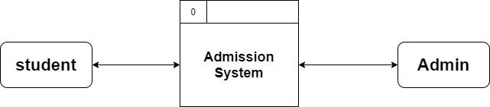

D. Draw the Dataflow Diagram of the system

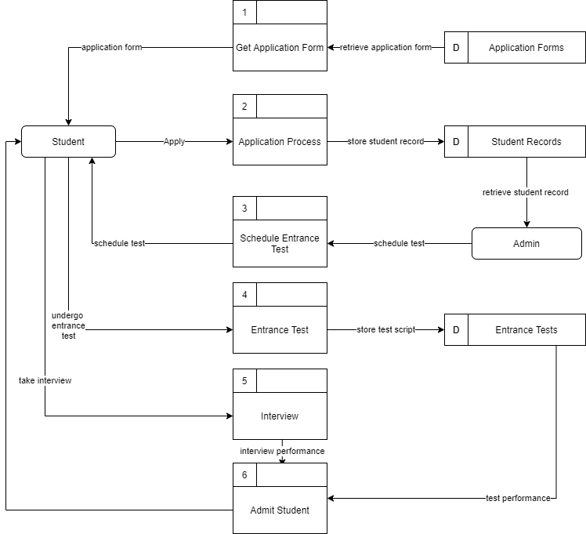

5. Draw the Entity Relationship Diagram of your system

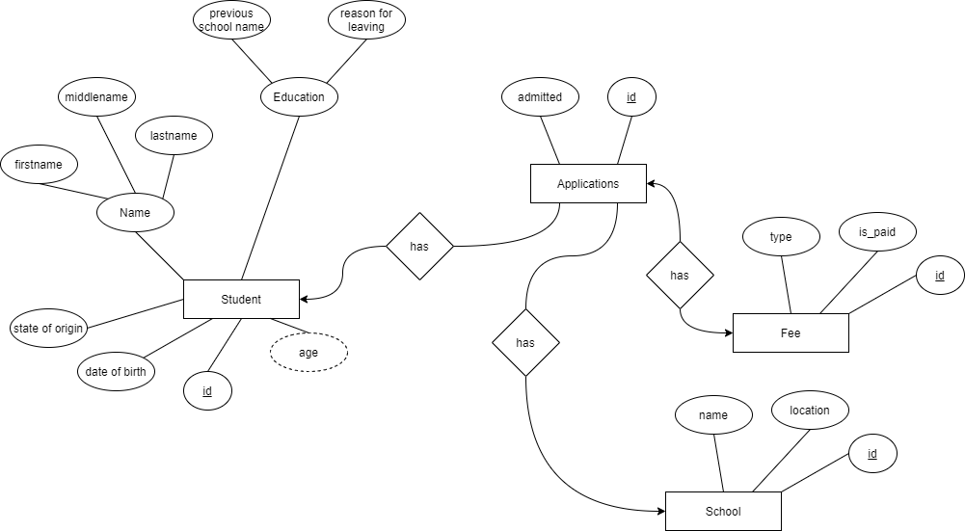

**Tool used to draw our below physical diagram is dbdiagram.io**

6. Translate the ERD into physical Database design, signifying primary & foreign keys where necessary

